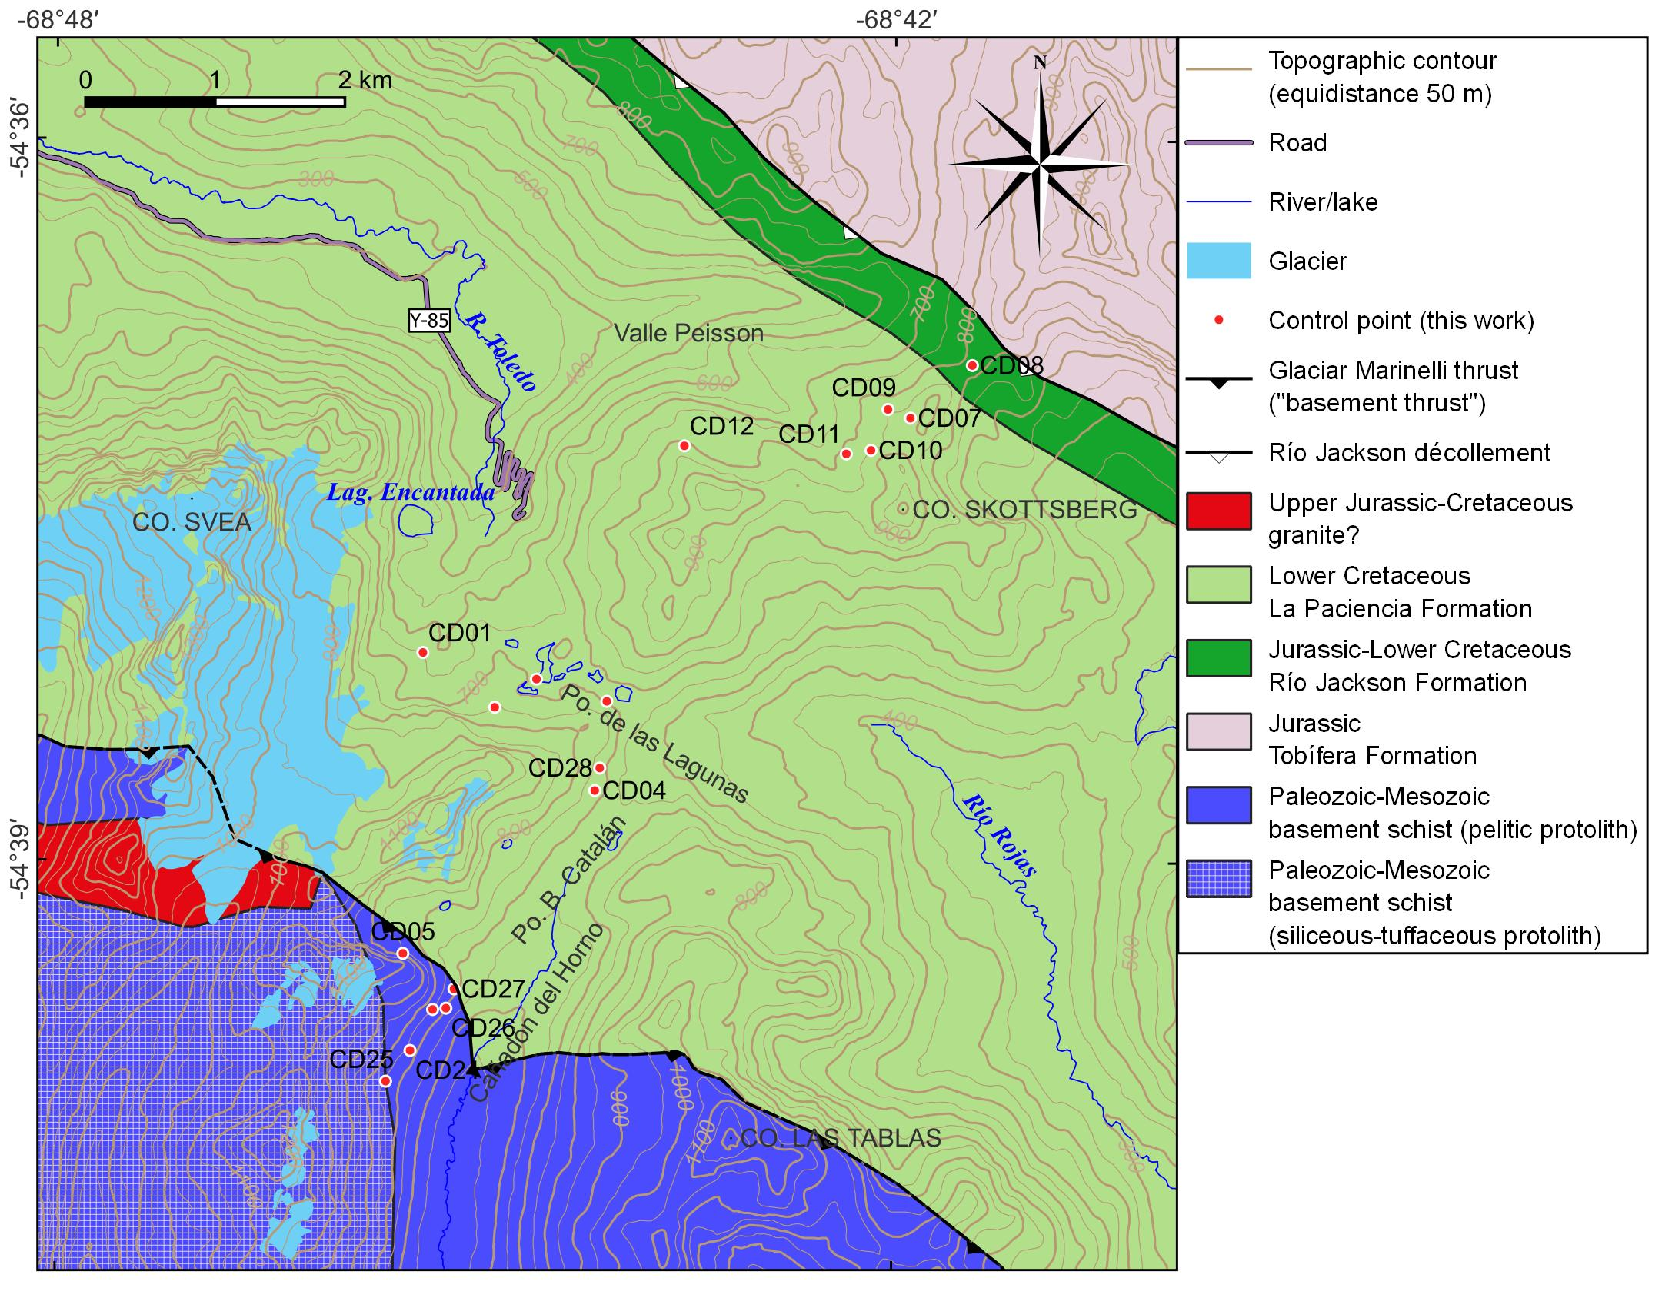
Geologic map published by Klepeis (1994), emphasizing the geologic units interpreted by this author in our study area. The position of the Glaciar Marinelli Thrust is slightly modified according to our own mapping (Fig. 2; see main text), the rest of the unit boundaries and labels are exactly as in the published map. Control points are included for an easy comparison with figure 2. The summit of Cerro Verde is ~2,700 m from the northern boundary of this map.

