Appendix B

W E

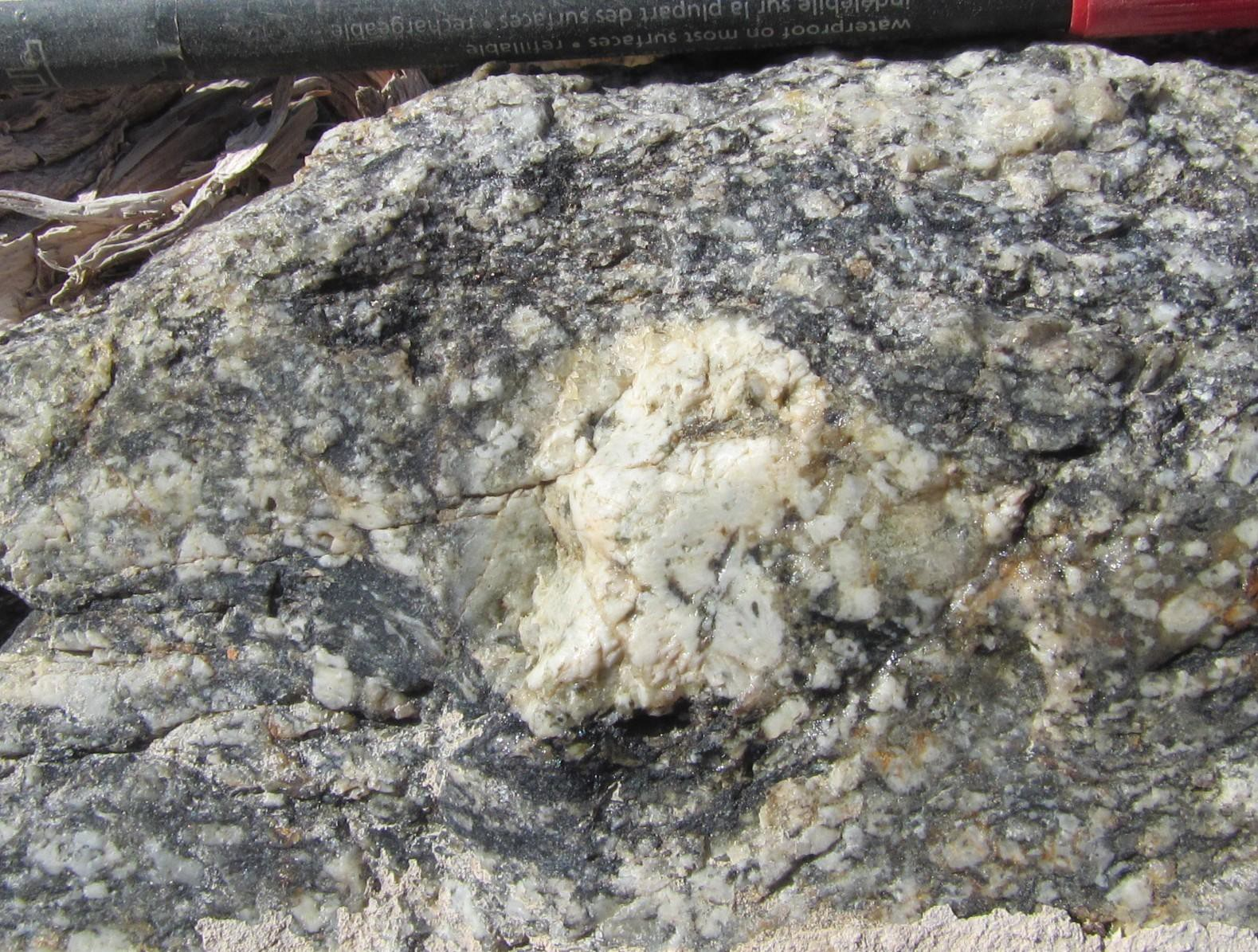Syn-tectonic sigma porphyroblast showing top-to-the-west sense of shear. Feldspar porphyroblast (white in centre) has been rotated, with asymmetric strain shadows of quartz.

W E

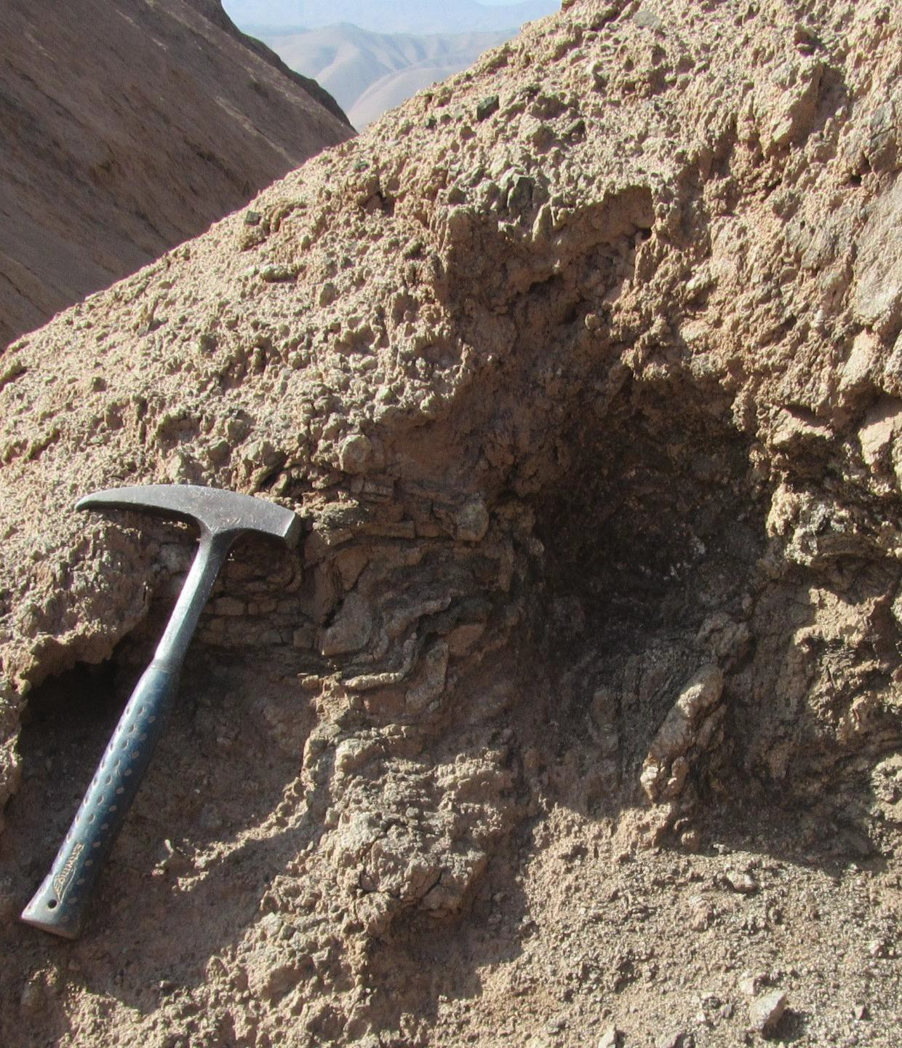Asymmetric overturned folds indicating westward tectonic transport. Note leucosome located at the hinge of folds.

S2

W E

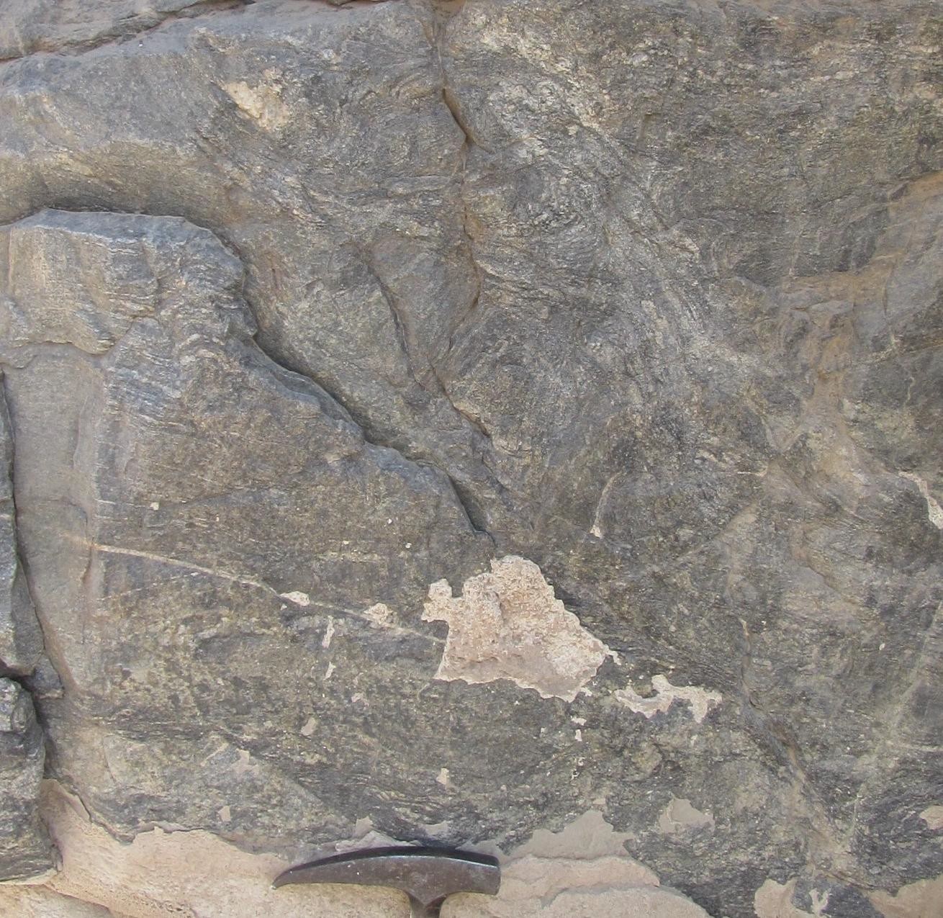Overturned folds (upper centre) indicating westward vergence. Leucosome at the hinges is affected by S2 foliation (white line). Deformation is associated with reverse shear bands (dashed black lines).

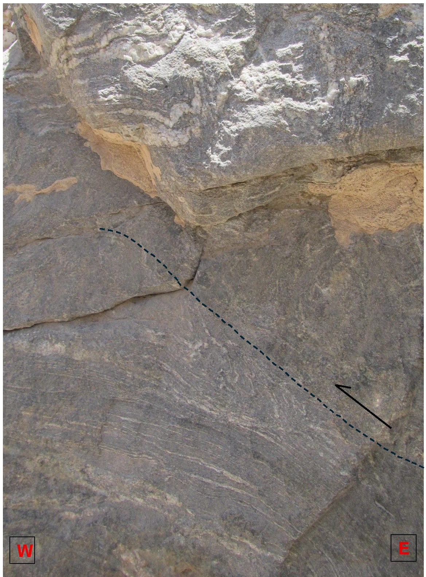

Overturned to recumbent centimetric folds associated with a low-angle reverse shear band (centre) showing top-to-the west transport.

NW SE

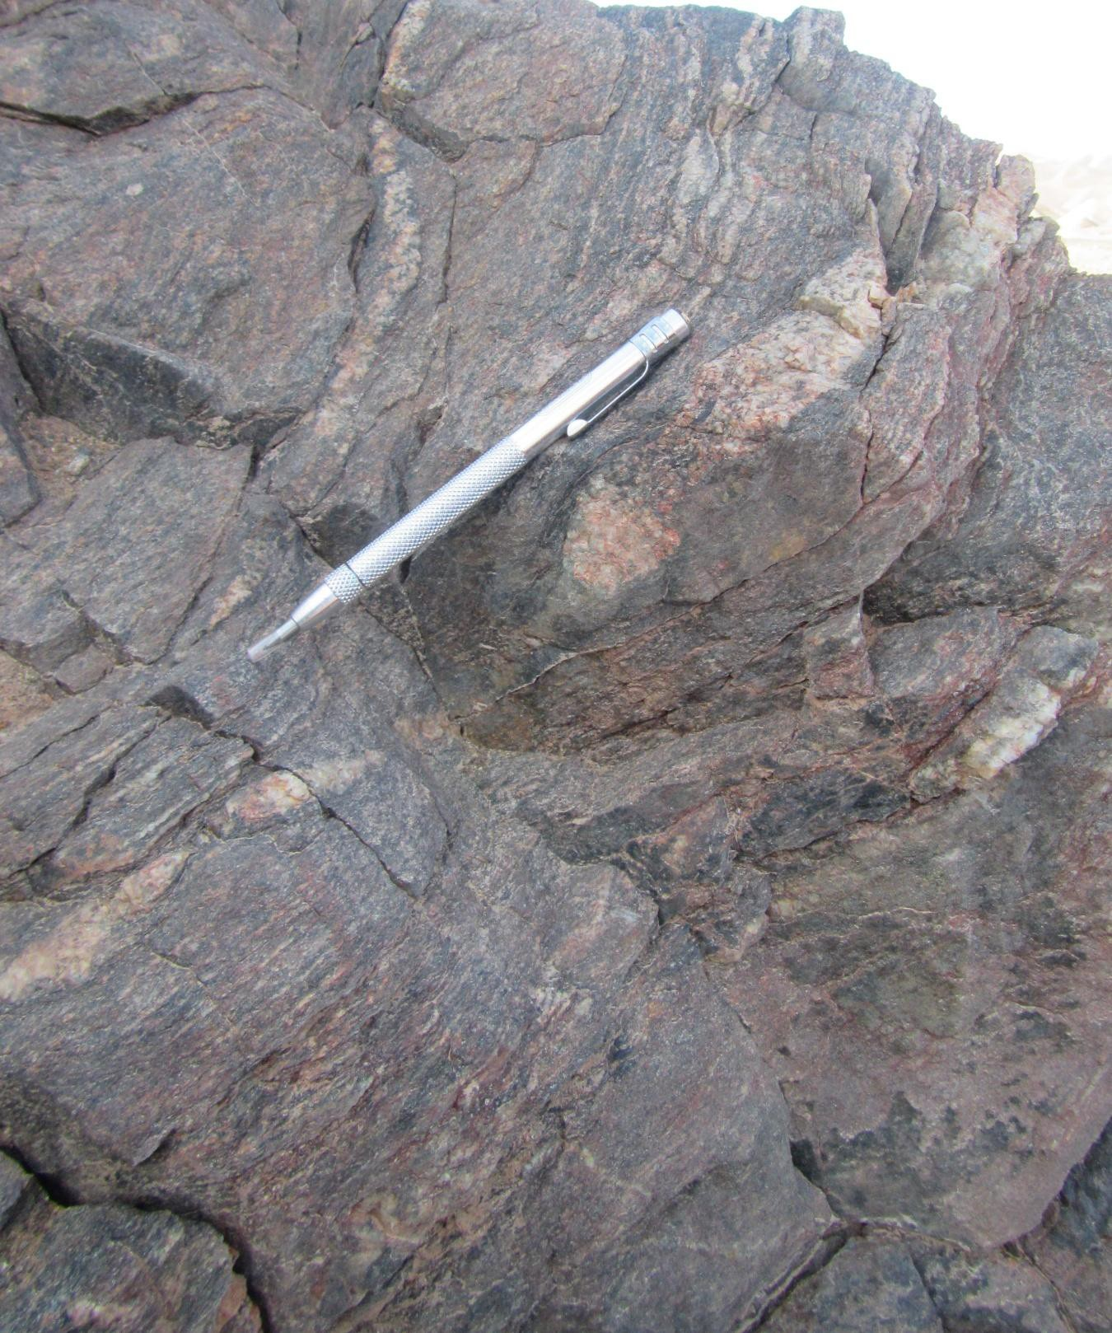Slightly discordant leucosome veins at the upper part of the Loa canyon, with pinch-and-swell structure and millimetric melanocratic selvedge.

